

End-user Documentation

for

Easy!Appointments

Students: Vladimir Stepanov

Wellington Silva

Index

Contents

1. How to get started 2

2. Filling the company information 3

3. Configuring the system 3

4. Requiring captcha for appointments 4

5. Sending notifications 4

6. Business logic 5

7. Adding new users 11

8. Adding categories 15

9. Adding services 16

10. Adding customers 17

11. Checking customers appointments 18

12. Adding appointment via Calendar 19

# How to get started

Accessing the Url provided by people who installed Easy!Appointments. You should see this page.

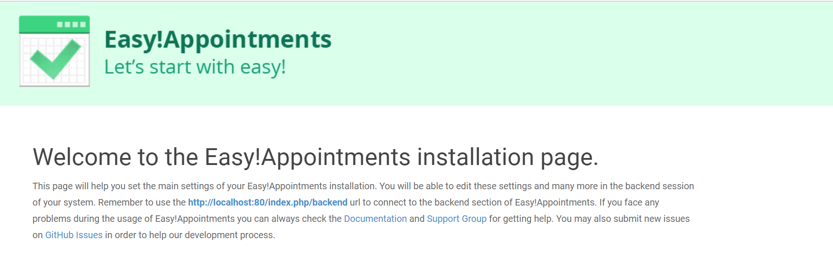

# Filling the company information

If you will be an System Administrator, you get to this page, where you will fill the form with the company information and create your user and password. The password must have at least 1 lowercase, 1 uppercase, 1 special character and 1 number. TAKE CARE OF THIS USER AND PASSWORD.

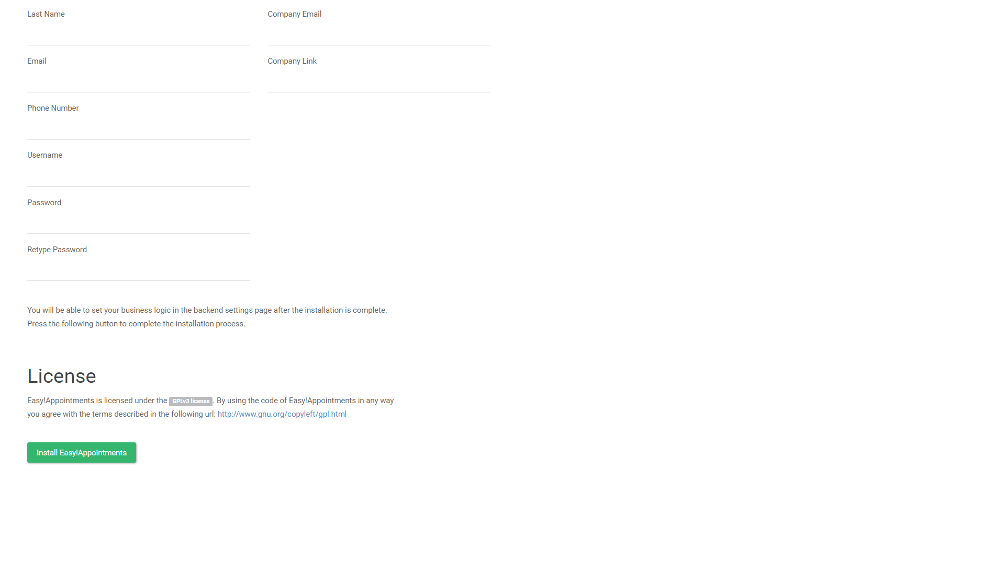

# Configuring the system

Click on “Settings”, this page will be displayed.

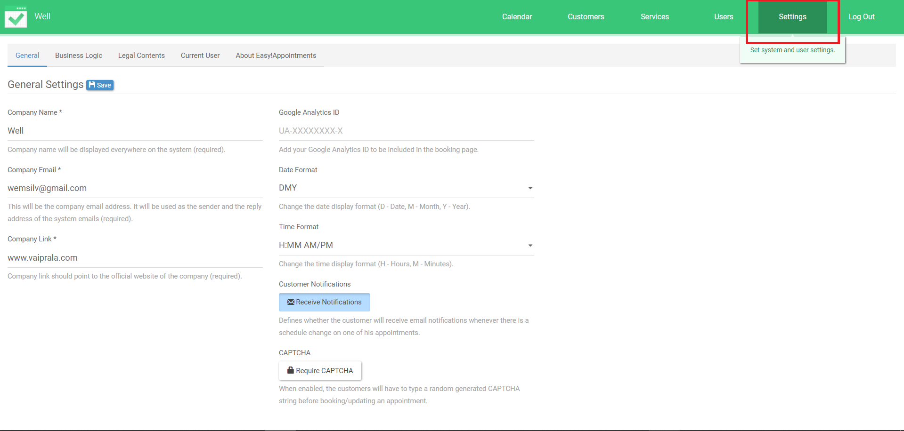

# Requiring captcha for appointments

You can require a captcha from users when they are creating their appointments

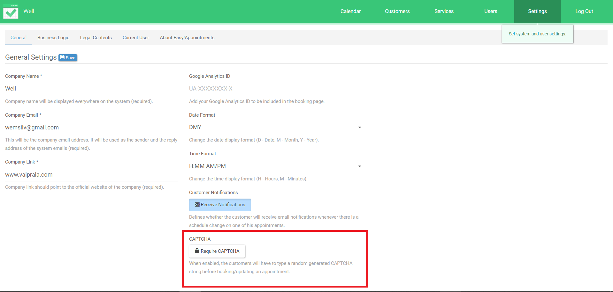

# Sending notifications

Select this option if you want Easy!Appointments to send confirmation email to users, when they make an appointment.

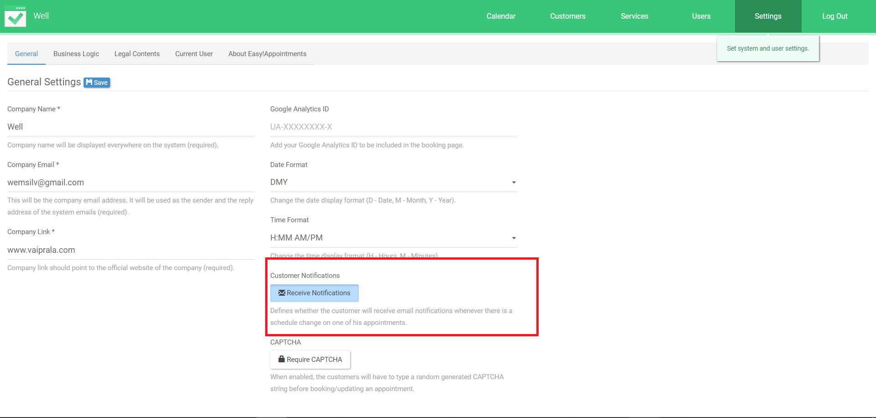

# Business logic

Here is where we define our working days and hours. It is important to define it now, so the customer can create an appointment only in the trading hour.

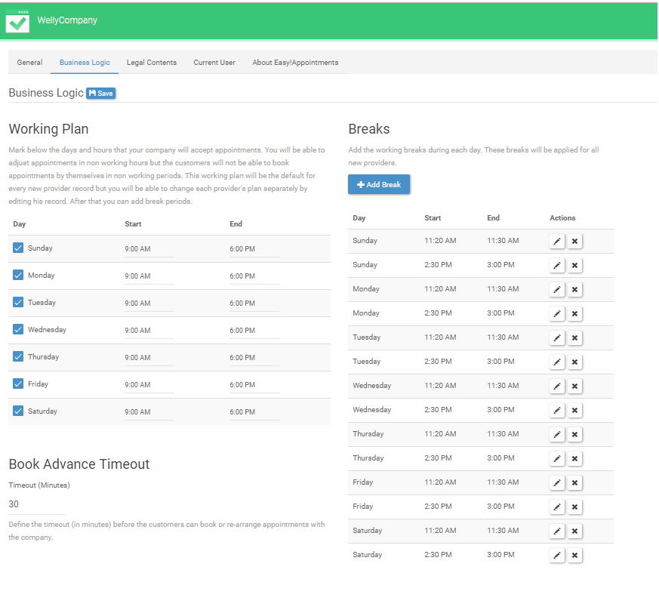

Select the days and hours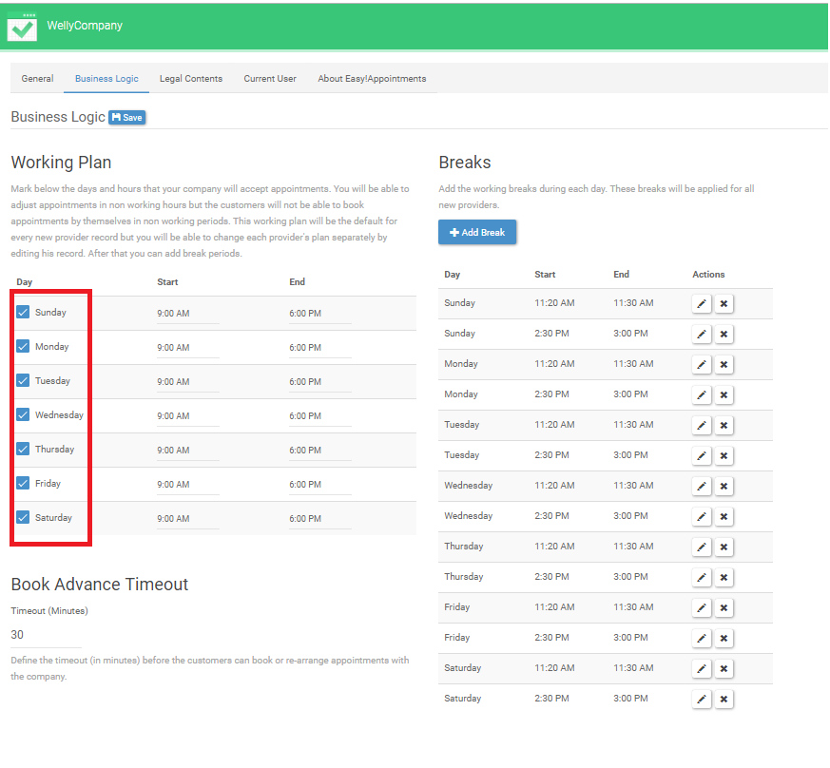

And then, add or remove breaks to them, if you want to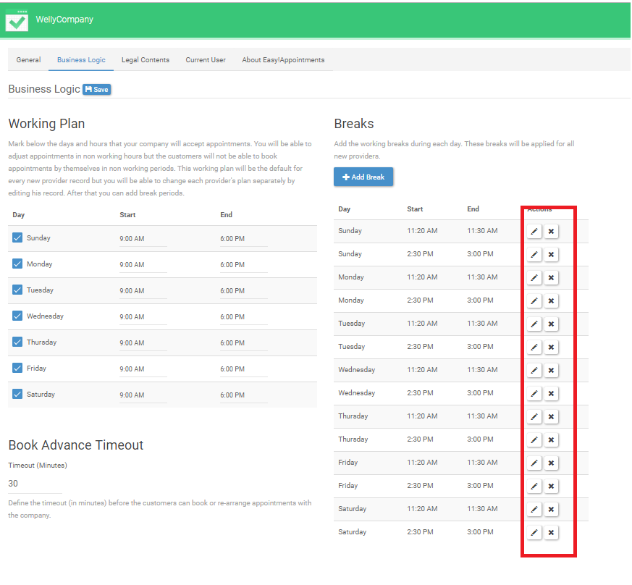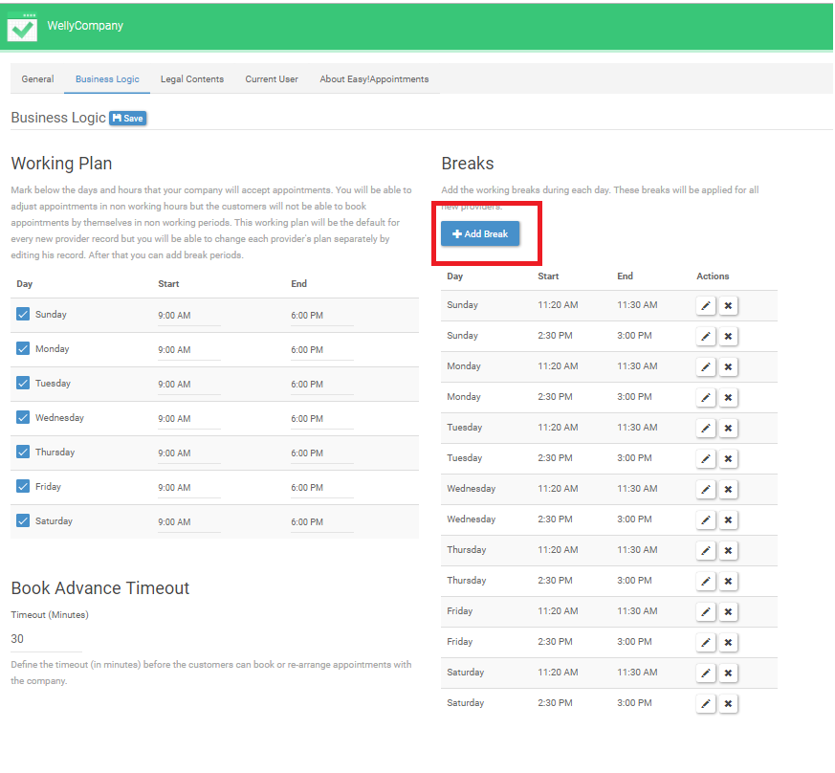

The duration of each break, can be defined here: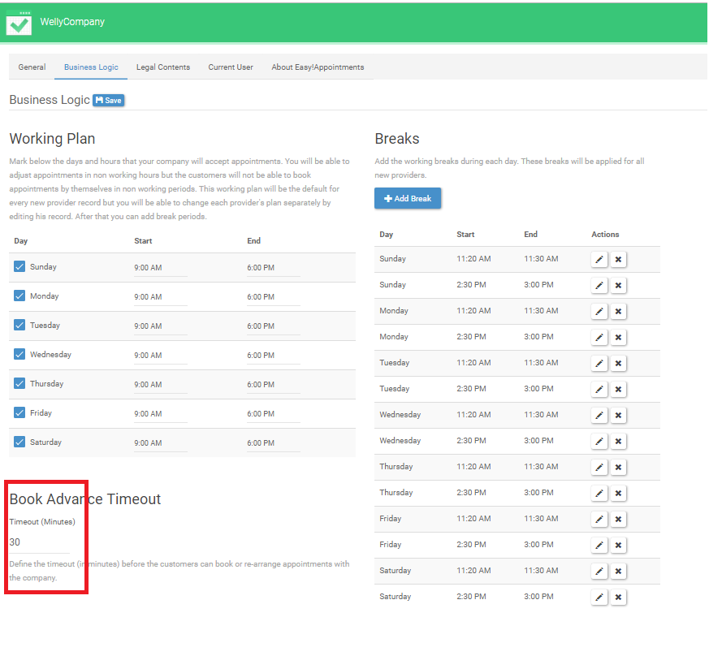

1. Adding new users

The users can be providers, secretaries or administrators. In the providers case, don’t forget to link they to services, that we will learn how to create in a moment. Also, when you are adding secretaries, you need to link them to a provider.

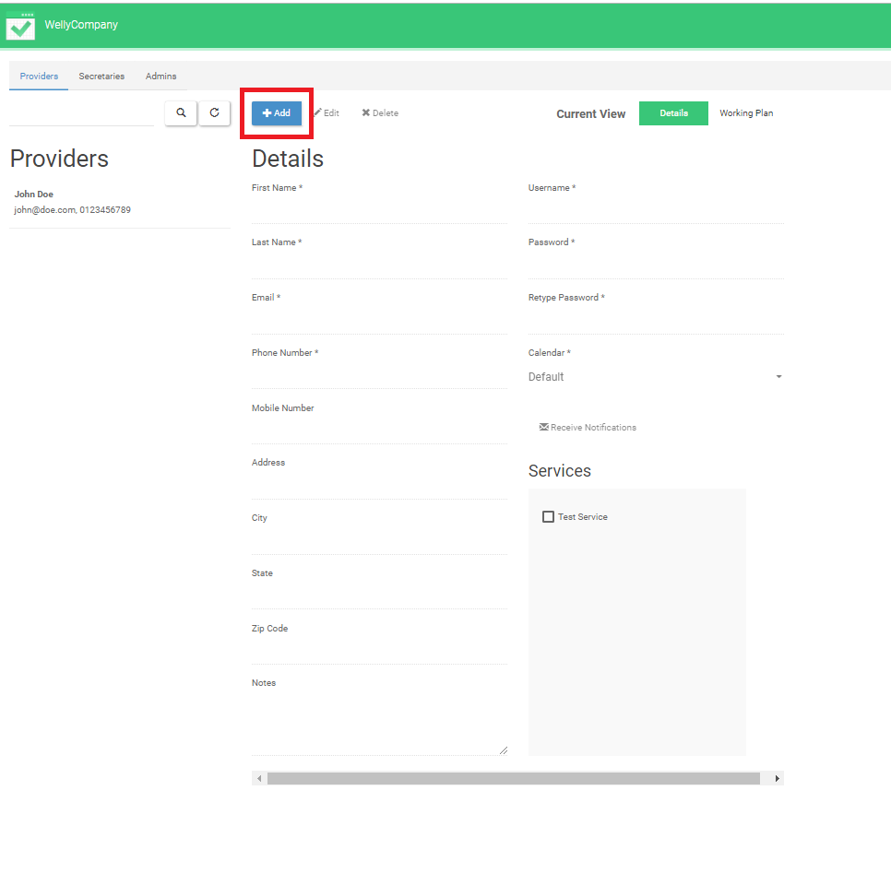

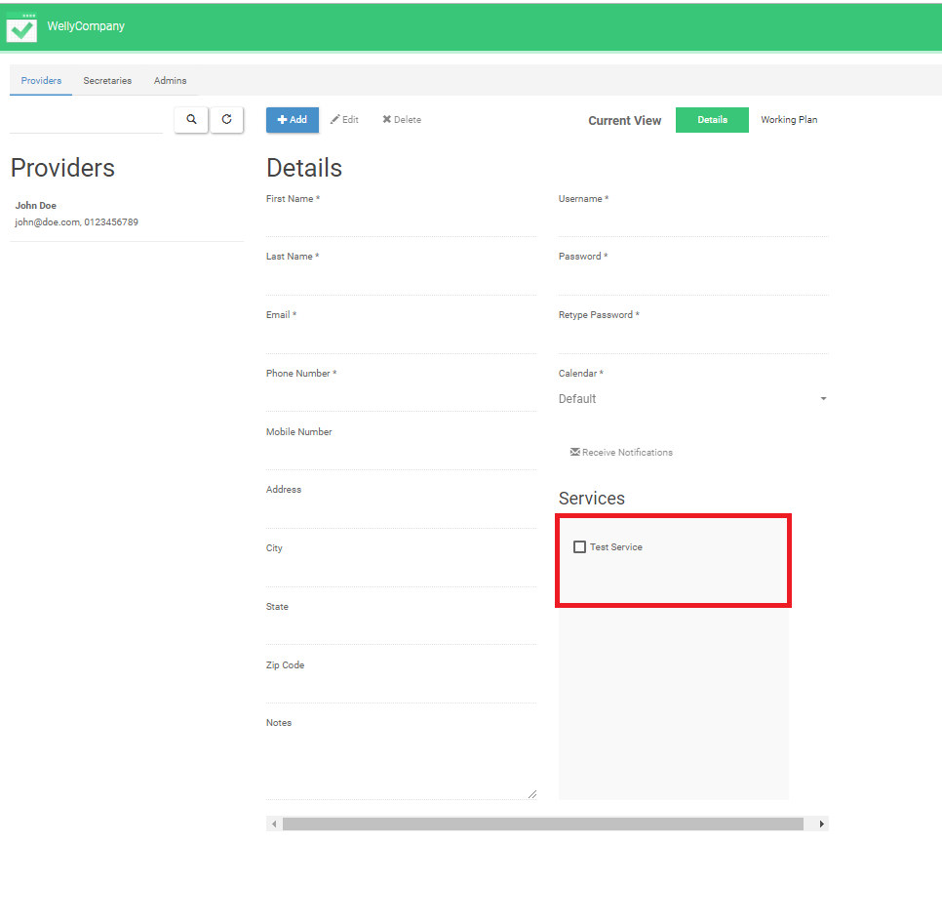

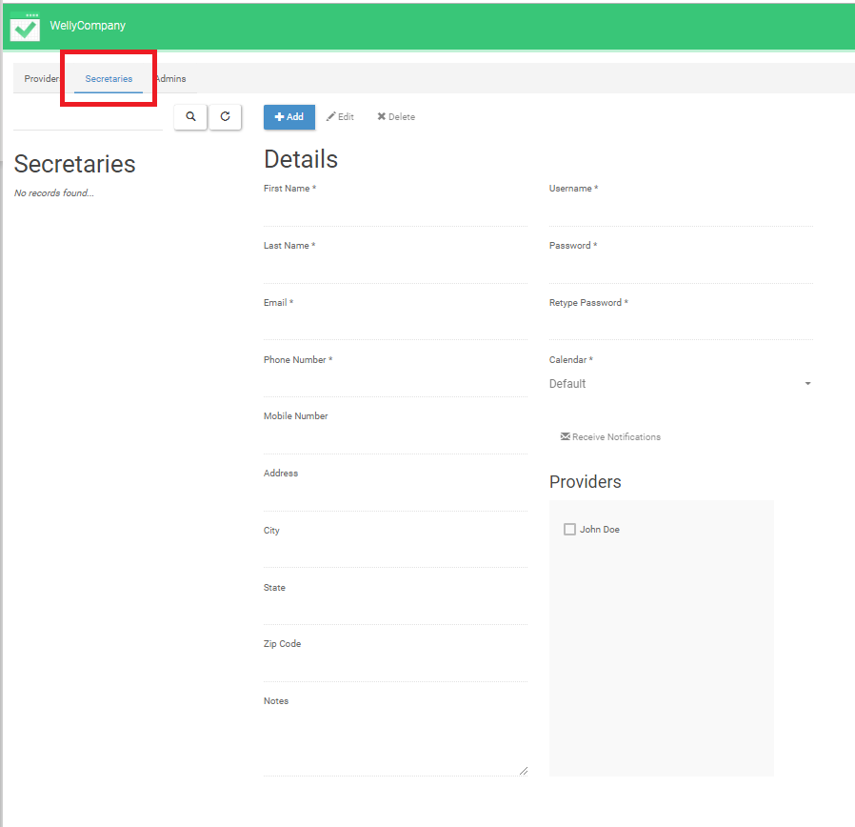

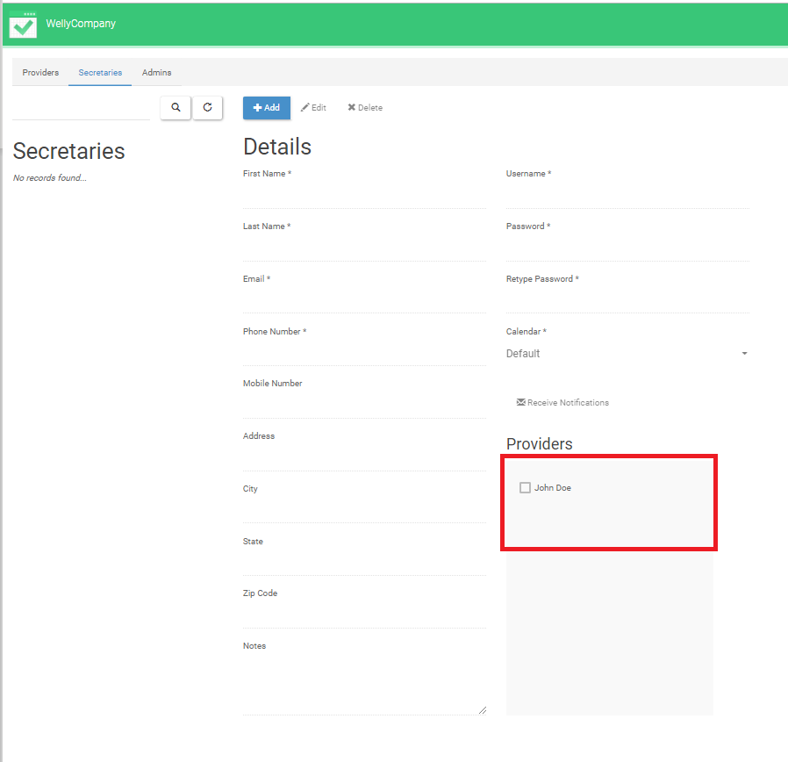

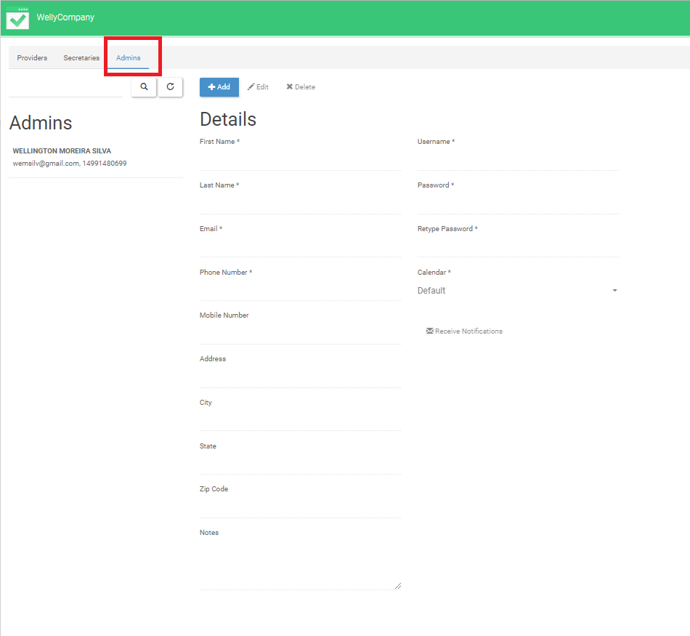

# Adding categories

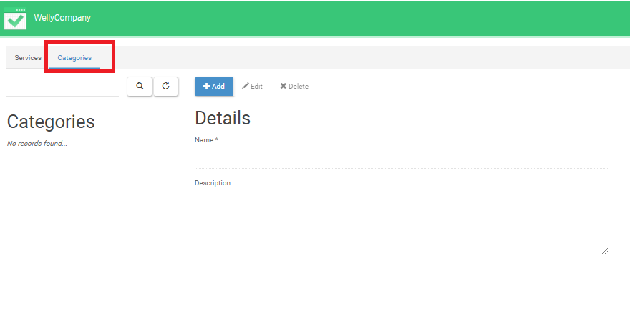

# Adding services

Very similar to add a category, but you can use the categories you have created before

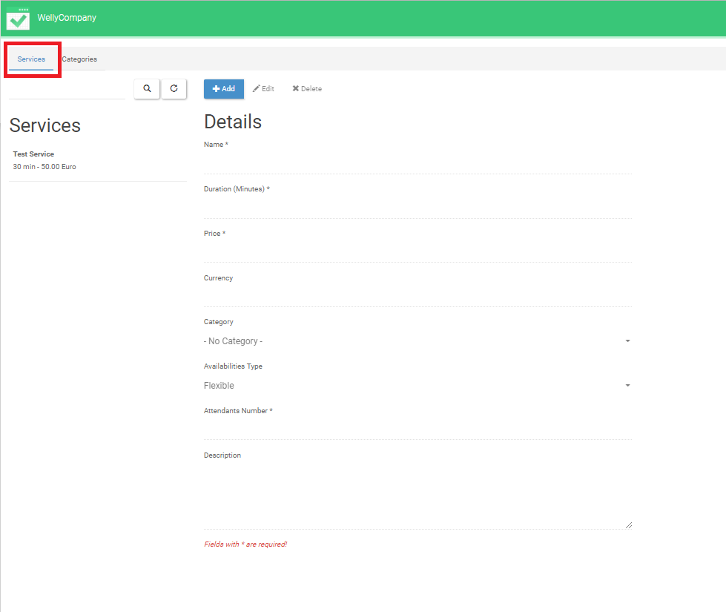

1. Adding customers

To add appointments via Calendar, you can use a customer registered before. This is the screen used to add customers 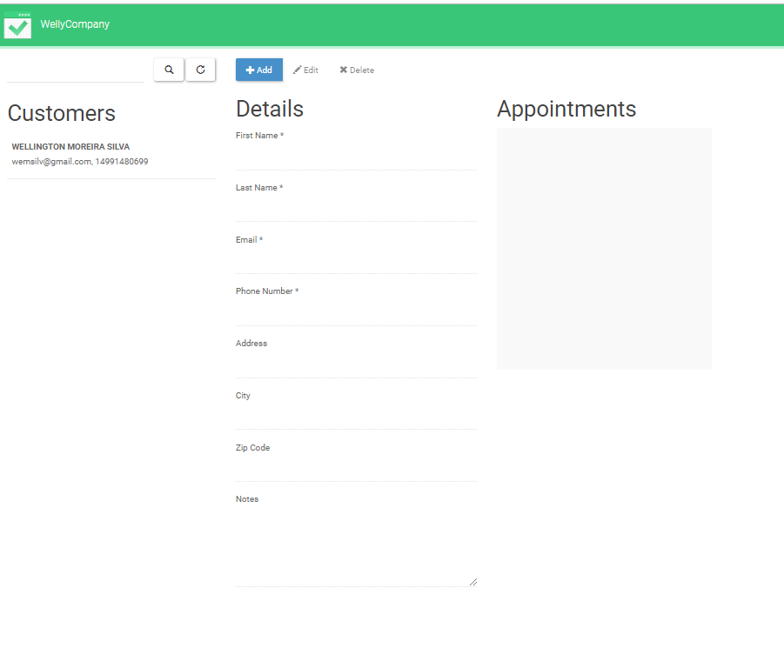

# 11. Checking customers appointments

After creating appointments, in the calendar screen or in the open screen, you can visualize the appointments by customer, in the customer screen:  
  
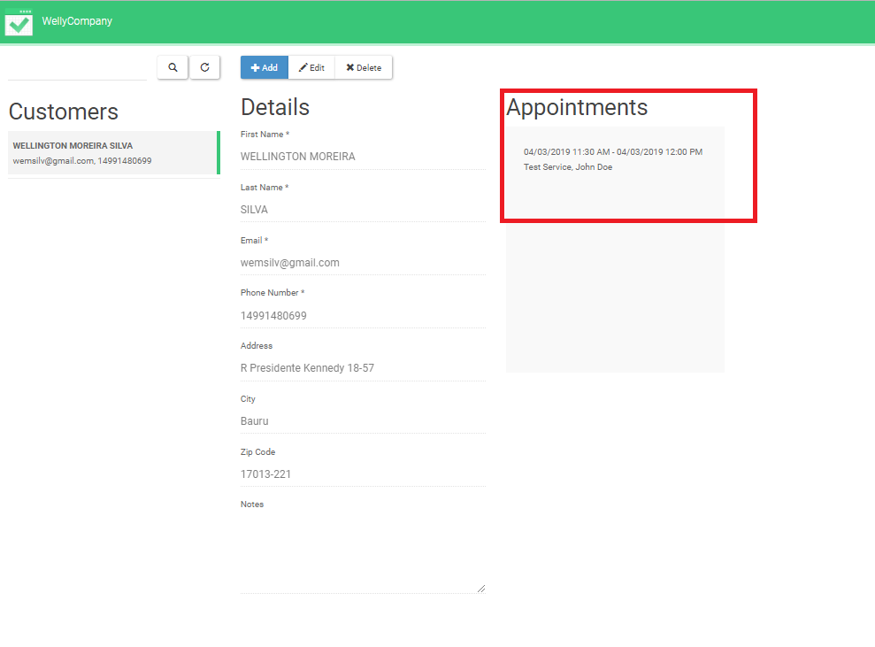

# 12. Adding appointment via Calendar

To add an appointment, in the backend page, go to the calendar screen and click on the white area, which correspond to the company’s working hours.

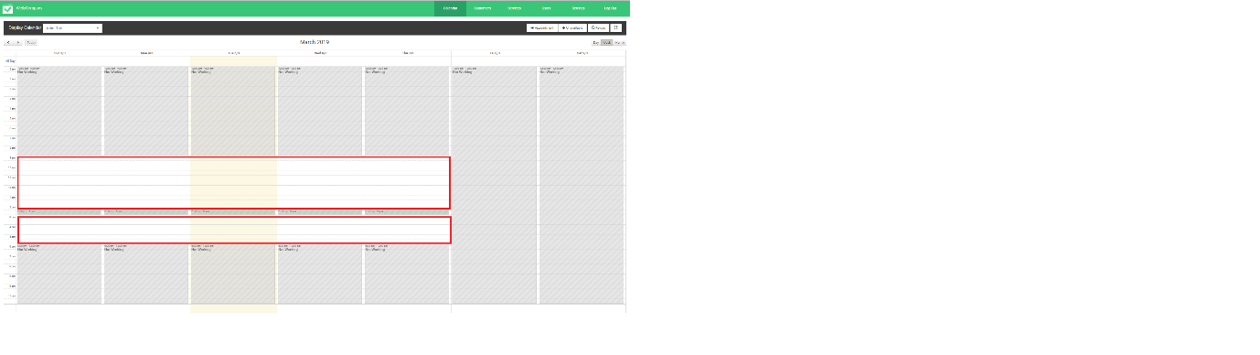

This screen will pop-up. Fill the information about the service, and then add a new user or select one created previously.

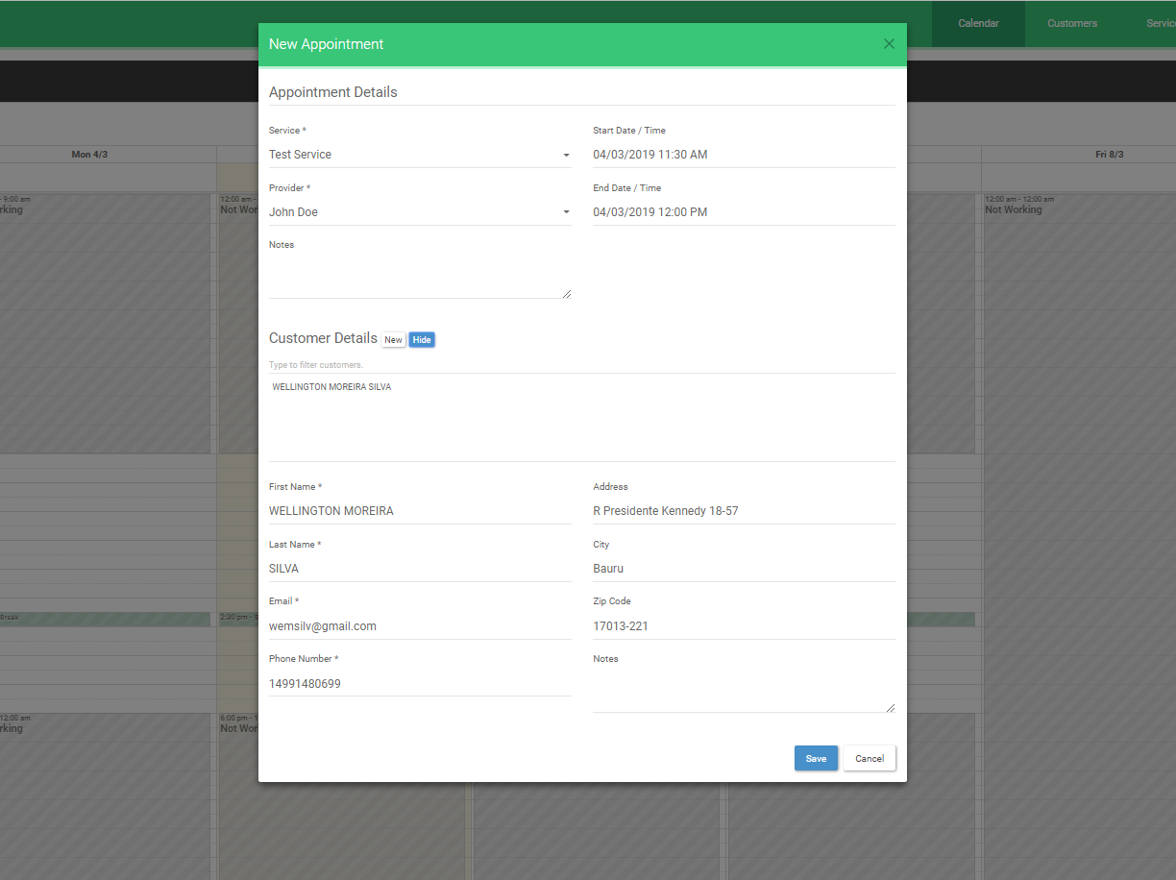

If everything worked as it should, you will see the appointment on the calendar:

